SE LAB-02:
SRN: PES1UG24AM380
SECTION :AIML-G

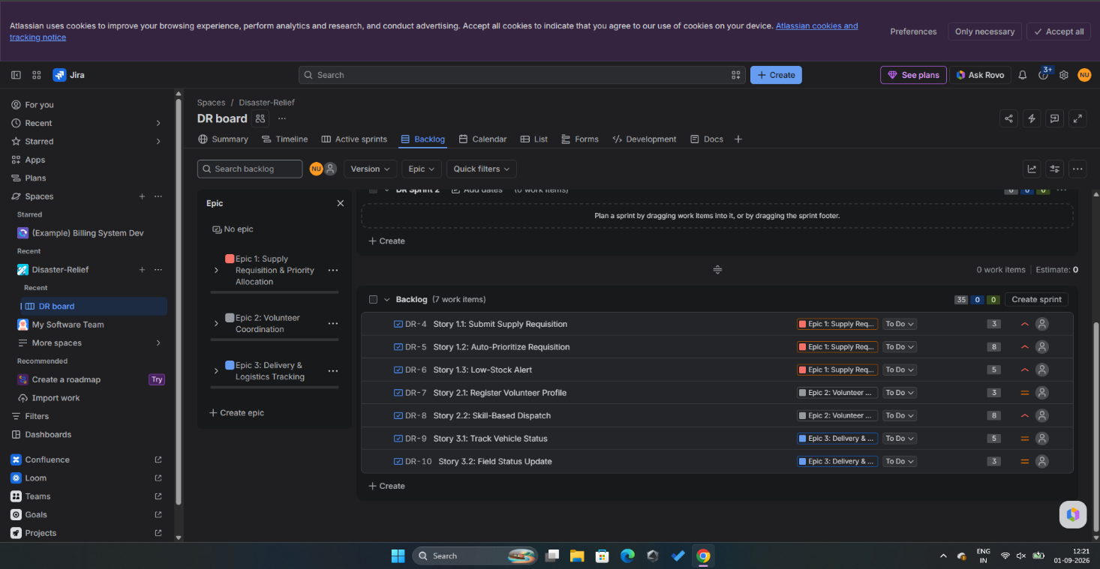
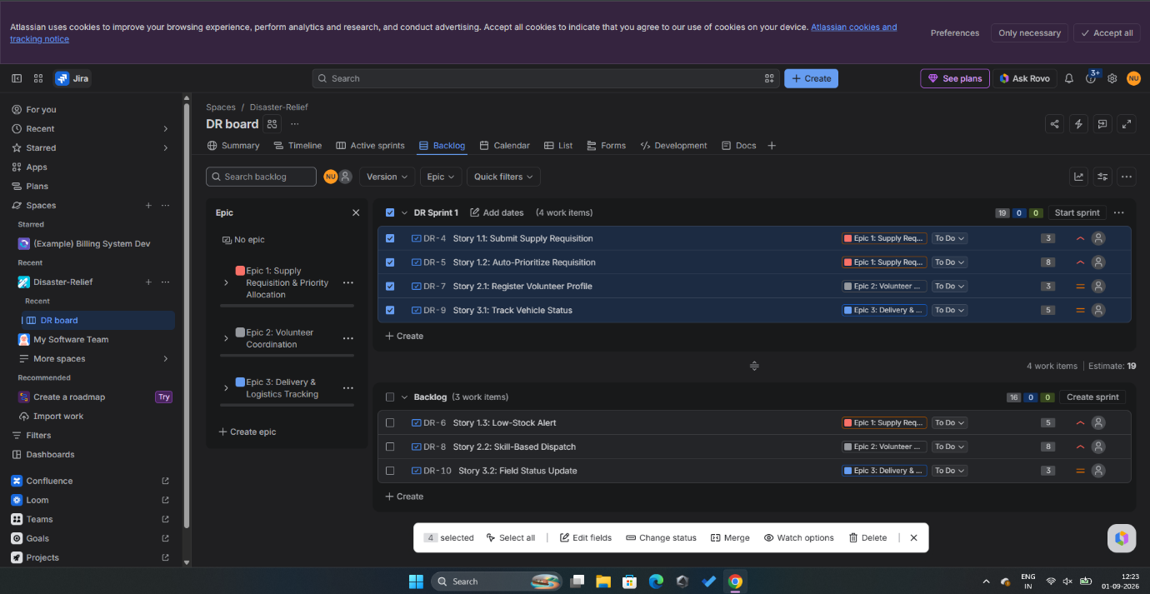

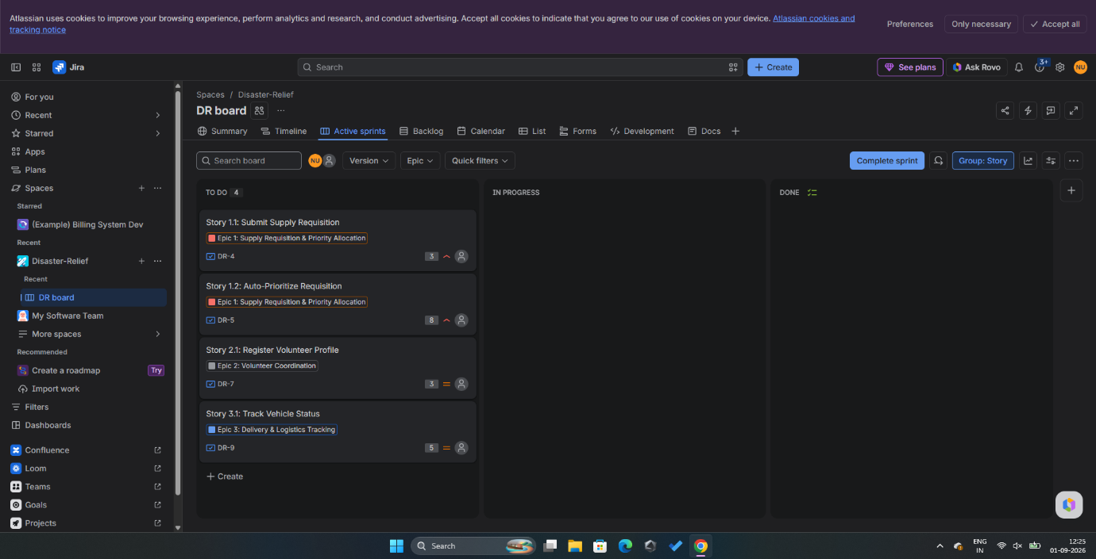
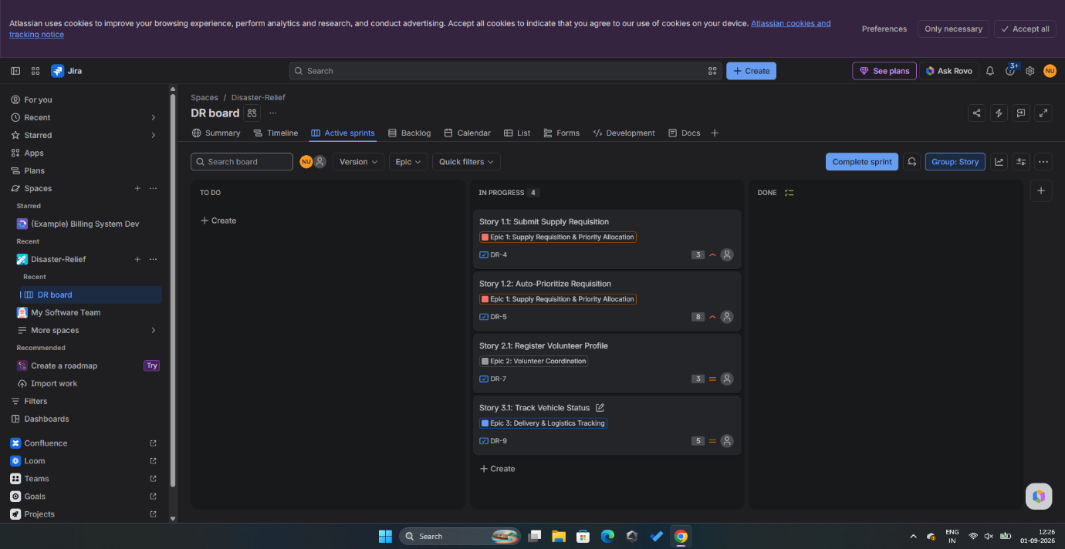
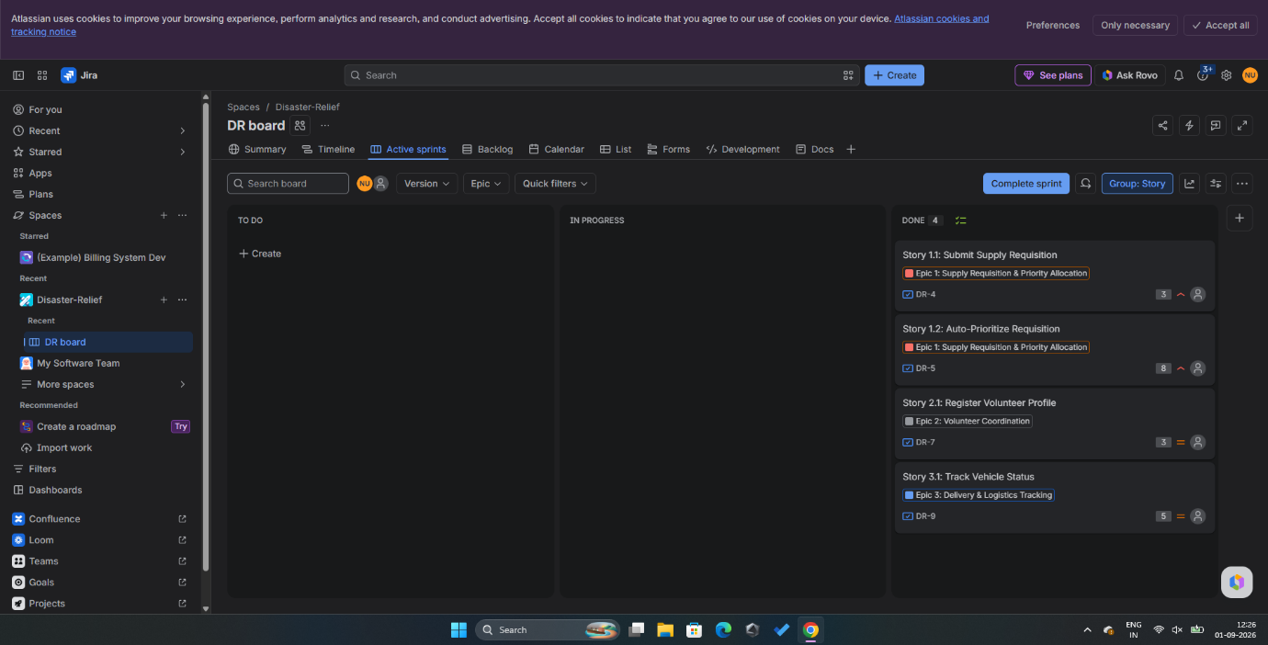
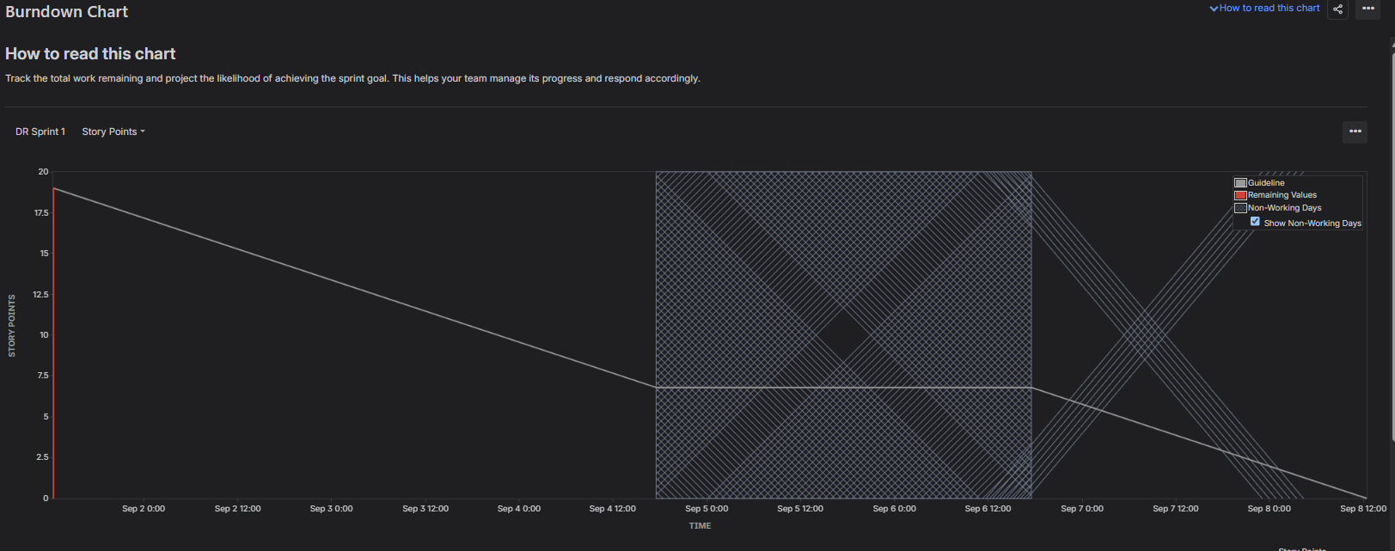
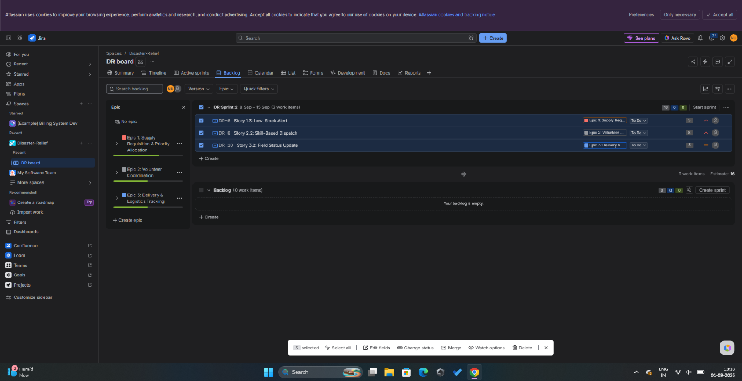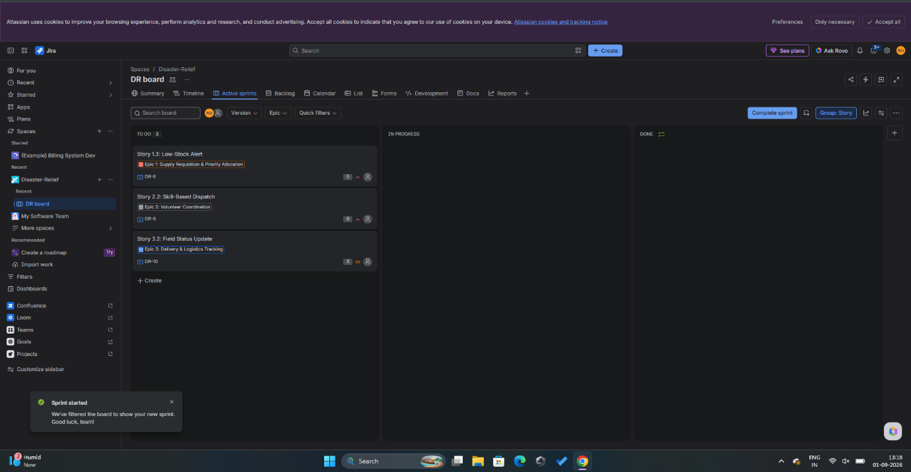
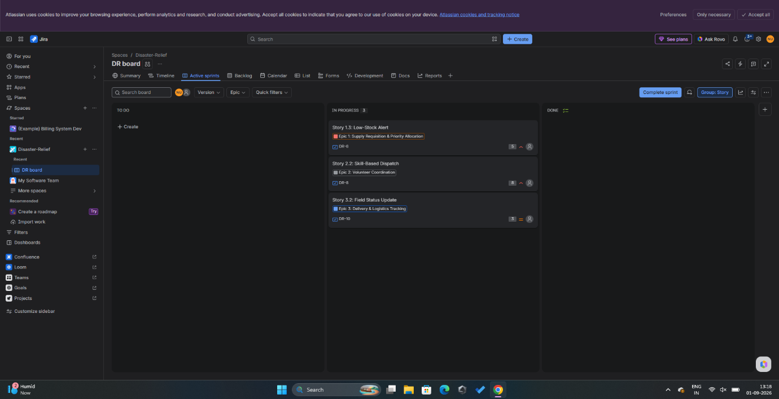
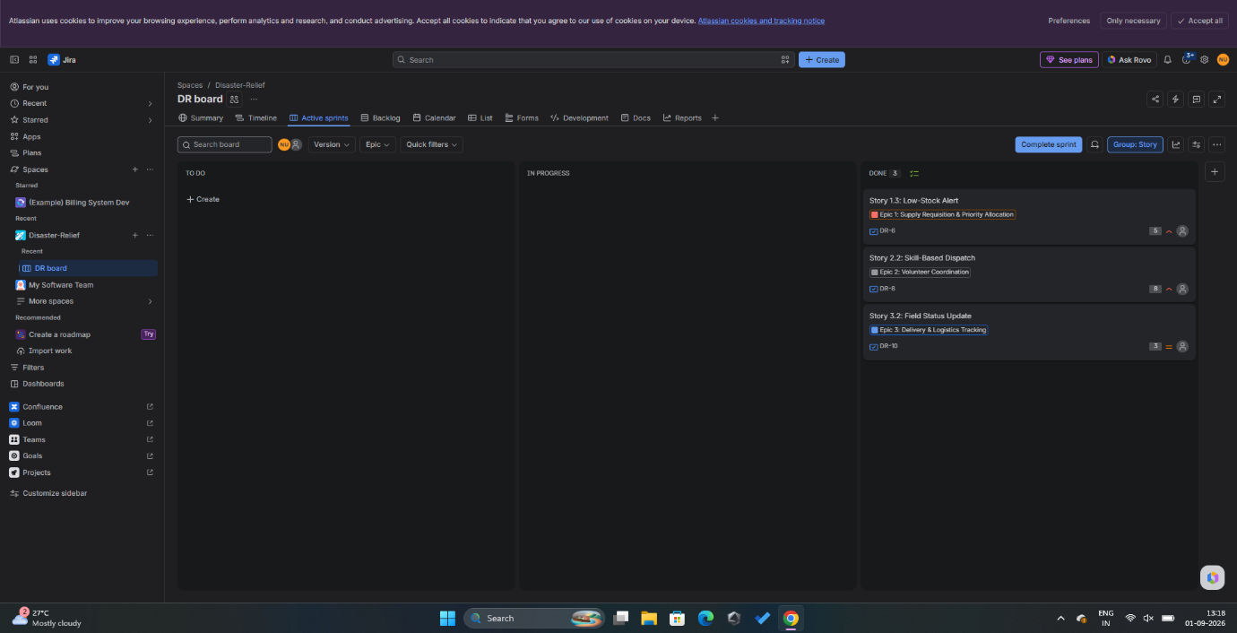

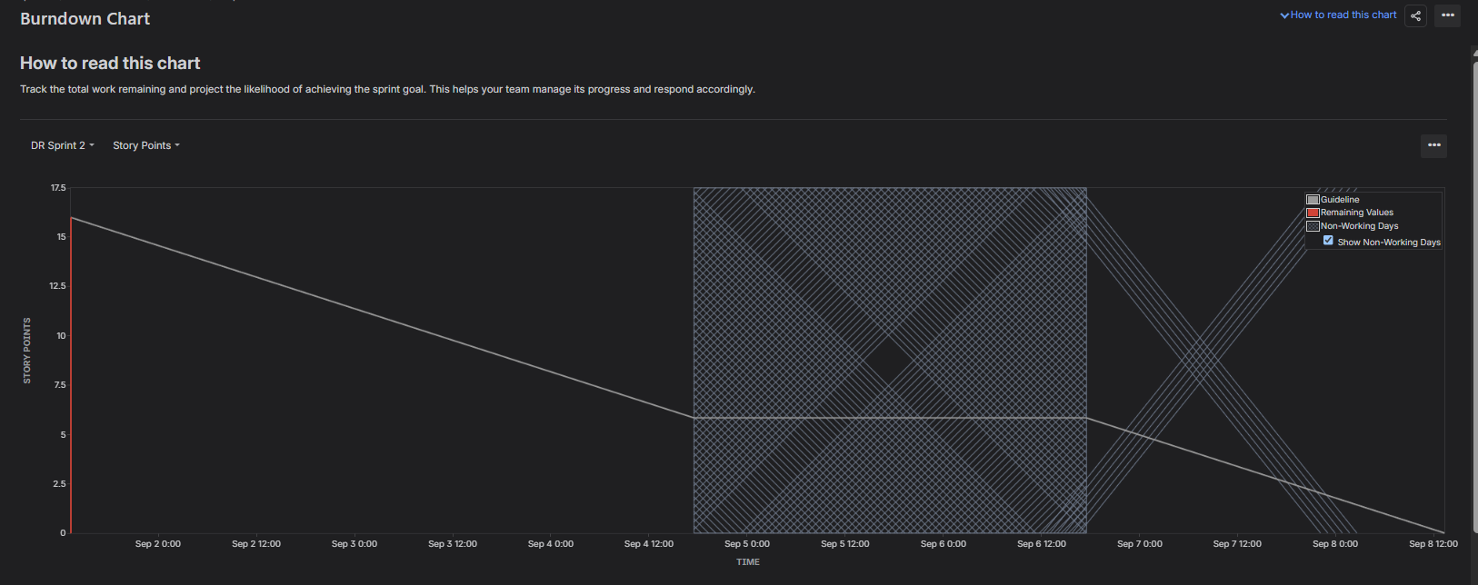
In a real-world scenario, a vertical drop to zero indicates that all work was finished instantaneously, reflecting artificial simulation rather than linear effort. In practice, using Fibonacci sequence estimation (3, 5, 8) accounts for uncertainty and complexity across full sprint days.
Was your backlog well-prioritized?
- Yes. The high-priority core workflow items (DR-4 Supply Requisition, DR-5 Auto-Prioritization, DR-7 Volunteer Registration, and DR-9 Delivery Tracking) were scheduled into Sprint 1, ensuring foundational capabilities were completed first.
How did your simulated sprint align with your plan?
- The sprint achieved 100% scope completion (19 of 19 points delivered), satisfying the goal of processing the primary requisition and tracking pipeline within the sprint container.
What insights did the burndown chart give about your team's capacity?
- The chart demonstrates that the initial commitment of 19 story points was fully burnt down. In active production, a sharp drop signals either underestimated story points or tasks that were not broken down into small enough daily deliverables.

